Watwin Scoring Deployment

1. Run the scripts in CreateErrorFixTimeStatsTable to
   1. Create the new schema
   2. Populate the M & SD

\*note: the table should truncate and repopulate periodically to get the up-to-dated statistic data (#b takes longer time as the data accumulates)

1. Deploy the new stored procedures
   1. [dbo].[GetBuildErrorMessages]
   2. [dbo].[GetWatwinScoringErrorTypeData]
   3. [dbo].[GetErrorFixTimeStats]
2. Alter the existing [dbo].[GetErrorQuotientErrorTypeData]
3. Update application code base, build, deploy …
4. Launch OSBIDE and go to “Analytics”, click through and get to “Choose Procedure and Parameters” view, select WatwinScoring from the procedure selection dropdown:

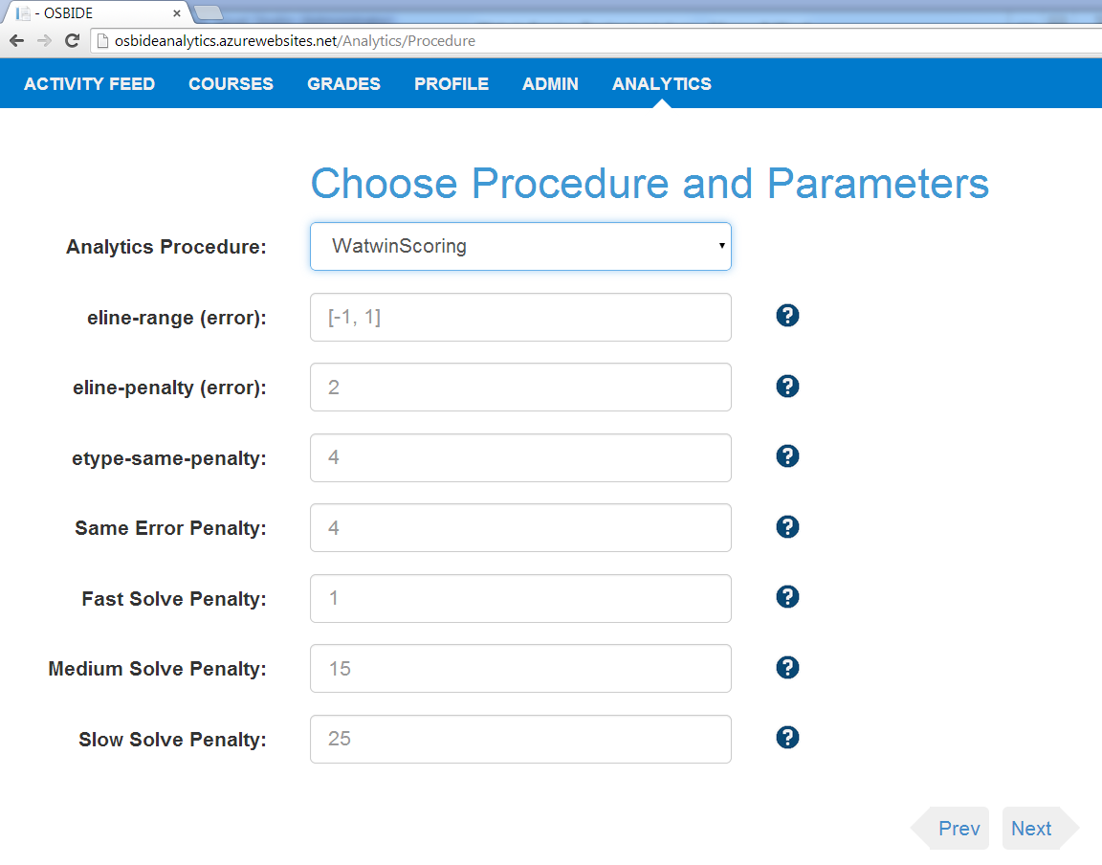

The set of WatwinScoring parameters can be adjusted through user interface. The results are presented in the exact same way as EQ except the labeling of the score.

